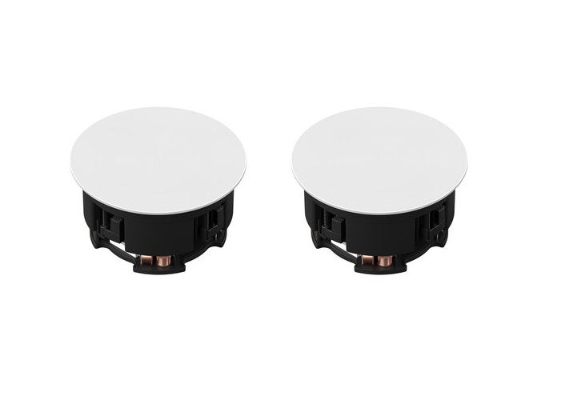

**Brand:**

Sonos

**Model:**

INCLGWW1

**Weight in Kg:**

2.2700

**Color:**

Black

**Dimension**

14.8 x 12.4 x 5.6"